Chapter 2, Problem 49.

Transform the circuits in Fig. 2.113 from Δ to Y.
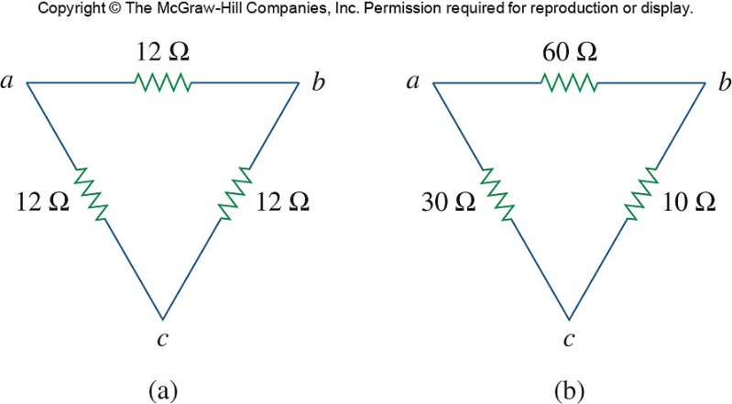

Figure 2.113
For Prob. 2.49.

